Самостоятелна работа -Гласните звукове и техните букви

Име на ученика: ___________________________________________І “в“ клас II група

1. Открийте буквите на гласните звукове. Оградете ги. 6т.

**Жж Зз Пп Ии Кк**

**Аа Фф Ее Гг Оо Рр**

**Вв Ъъ Цц Уу Тт Юю**

2. Диктовка. 12т.

3. С кой звук започва всяка дума? Напишете неговата главна и малка ръкописна буква.

4т.



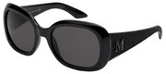



4. Направете звуков модел на думите. Разделете думите на срички. 6т.

[](http://images.google.bg/imgres?imgurl=http://igrushka.kz/vip60/kor_b.gif&imgrefurl=http://tuci.lovelyforum.net/forum-f70/topic-t2771.htm&usg=__-jkWrGnLx4t0V1th3UqcnGWxC3Y=&h=586&w=595&sz=8&hl=bg&start=3&um=1&tbnid=zYcKJ3cY1BRlrM:&tbnh=133&tbnw=135&prev=/images%3Fq%3D%25D0%25BA%25D0%25B0%25D0%25BB%25D0%25B8%25D0%25BD%25D0%25BA%25D0%25B0%26imgc%3Dgray%26hl%3Dbg%26rlz%3D1T4ADSA_enBG350BG350%26sa%3DN%26um%3D1)[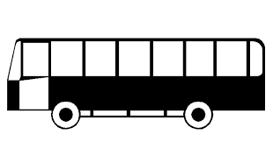](http://images.google.bg/imgres?imgurl=http://www.tsingma.com.hk/Web_pages/Toll_fee/7_public_single_bus.gif&imgrefurl=http://www.tsingma.com.hk/Web_pages/Toll_fee/test_toll_fee_e.htm&usg=__lqxpXN8jDCeWg07-ul6s_2pv8NI=&h=381&w=727&sz=7&hl=bg&start=24&um=1&tbnid=GvlLcEeEyindJM:&tbnh=74&tbnw=141&prev=/images%3Fq%3D%25D0%25B0%25D0%25B2%25D1%2582%25D0%25BE%25D0%25B1%25D1%2583%25D1%2581%26imgc%3Dgray%26imgtbs%3Dtc%26imgtype%3Dclipart%26ndsp%3D20%26hl%3Dbg%26rlz%3D1T4ADSA_enBG350BG350%26sa%3DN%26start%3D20%26um%3D1)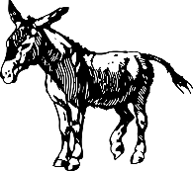

  

5. Напишете буквите на гласните звукове. 5т.

[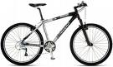](http://images.google.co.uk/imgres?imgurl=http://rowery.onet.pl/_i/sprzet/rowery/600/60.jpg&imgrefurl=http://hasenchik.net/%3Fm%3D200810&usg=__2r_thoPZLJspPZq78DzXYEehPtg=&h=360&w=600&sz=43&hl=en&start=6&um=1&tbnid=lt0NRIWQOQkmAM:&tbnh=81&tbnw=135&prev=/images%3Fq%3D%25D0%25BA%25D0%25BE%25D0%25BB%25D0%25B5%25D0%25BB%25D0%25BE%26hl%3Den%26rlz%3D1I7ADSA_en%26sa%3DN%26um%3D1)[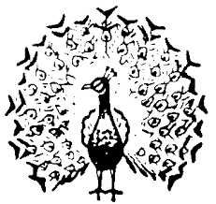](http://images.google.co.uk/imgres?imgurl=http://www.gocek.org/christiansymbols/images/peacock.gif&imgrefurl=http://www.gocek.org/christiansymbols/%3Fsearch%3Danimal&usg=__7vWHx0KGU6mSSLbfuWUjRmq5efM=&h=304&w=321&sz=6&hl=en&start=3&um=1&tbnid=V7uv2CFTMKfolM:&tbnh=112&tbnw=118&prev=/images%3Fq%3Dpeacock%26imgc%3Dgray%26hl%3Den%26rlz%3D1I7ADSA_en%26sa%3DN%26um%3D1)

 

6. Препиши с ръкописни букви вярно и красиво.

У, о, А, и, ъ, Е, а, у, И, е, О, Ъ 12т.

ау, ее, ие, оу, уъ, еа

**Скала за оценка:**

42 – 45 т. Отличен

38 – 41 т. Много добър Брой точки:

32 – 37 т. Добър

23 – 27 т. Задоволителен ( среден )

0 – 22 т. Незадоволителен резултат (слаб) Оценка:

Проверил:

Родител: